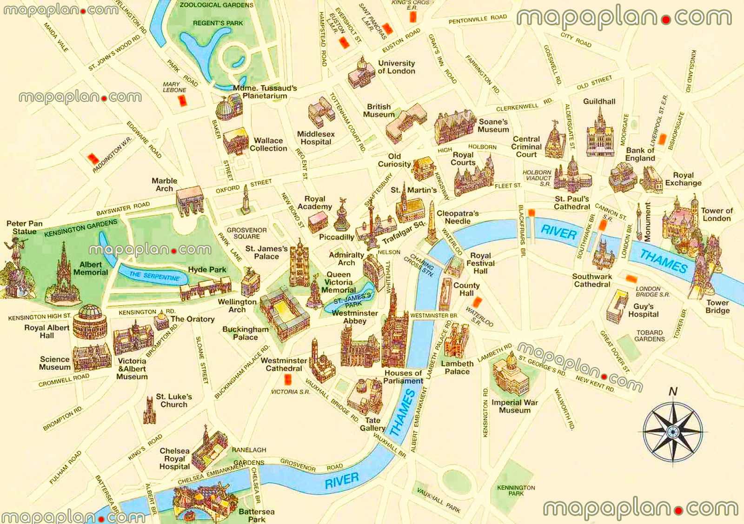

About the landmark

Carousel of landmark

Logo